PROJECT METHODOLOGY- ABDUL & SARAN
A. Desk-Based Data Sources:
For this project, we will primarily utilize desk-based data sources provided by the National Health Service (NHS). These sources include Monthly and Annual Data Reports such as "Energy Regression Monthly Report 23" and "Master Copy 22-23." These reports contain detailed information on energy consumption across various NHS hospitals and clinics in Swansea. Additionally, we will rely on internal documents and reports related to energy management strategies within NHS facilities. These desk-based data sources are essential as they provide comprehensive insights into energy usage patterns and costs, enabling us to analyse and identify opportunities for cost savings effectively.

B. Criteria for Evaluation:
In evaluating the desk-based data sources, we will employ the following criteria in our project aimed at analysing energy data to drive cost savings within NHS facilities in Swansea, very carefully assessed the data sources in imperative to ensure the effectiveness of our analysis. We initiate the process by carefully evaluating the relevance of the data, specifically targeting information on energy consumption patterns, costs, and trends pertinent to NHS facilities in the region. This ensures that our analysis remains sharply focused on elements essential for achieving our project objectives and implementing efficient cost-saving measures. Accuracy is equally paramount; hence, we conduct thorough examinations to verify the reliability of the data sources, meticulously checking for any discrepancies or errors that might compromise the integrity of our analysis. Furthermore, we emphasize the importance of timeliness, favouring data sources that provide up-to-date information reflecting recent trends in energy consumption within NHS facilities. Through a rigorous evaluation process based on these criteria, we aim to derive robust insights and develop effective strategies for achieving significant cost savings across NHS facilities in Swansea.
C. Project Implementation:
The project will be implemented following a structured approach outlined in our group planning documents.
I. Gantt Chart of Project Tasks:
In our project group, each member has been assigned specific tasks to complete, and we've laid out a timeline for when each task should be finished. One member started by defining the project's aim and objectives, which took about two weeks. Then, two members worked together to write a summary of the project, which lasted for two weeks as well. At the same time, another pair of members focused on writing an introduction to the project, explaining why it's important to analyse energy data from NHS facilities.
After that, two other members researched energy management principles and cost-saving strategies relevant to our project, which took about two weeks. Following this, another pair of members developed the methodology for the project, detailing how we'll clean, analyse, and visualize the energy data. This part of the project lasted for two weeks as well.
During the last two weeks of the project, two members concentrated on identifying any potential problems, risks, or ethical issues we might encounter along the way. This involved looking ahead and thinking about how we can solve any problems that might arise. Throughout the project, all members worked together to compile references and additional materials for the final report.
By dividing up the work this way and setting clear deadlines, we ensure that each aspect of the project progresses smoothly and that we're all on track to meet our goals.
Gantt chart image:
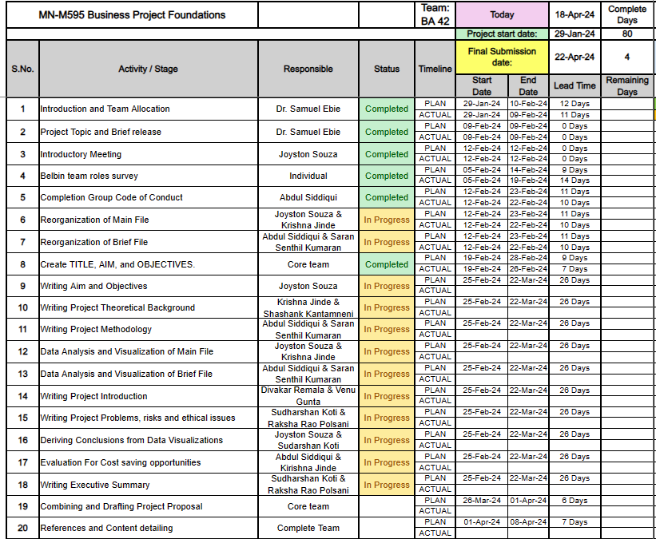
The screenshot is Project Task Assignment Gantt Chart reflecting clear delineation of responsibilities and deadlines among team members for coordinated project completion.
II. Key Milestones:
Project Kick-off Meeting
This milestone marks the official commencement of the project, where team members and stakeholders convenient to initiate the project's activities. During the kick-off meeting, project leaders will provide an overview of the project's objectives, scope, and timeline. Roles and responsibilities will be allocated to team members, ensuring clarity and accountability throughout the project. Additionally, the kick-off meeting serves as an opportunity to establish communication channels and address any initial queries or concerns raised by team members or stakeholders.
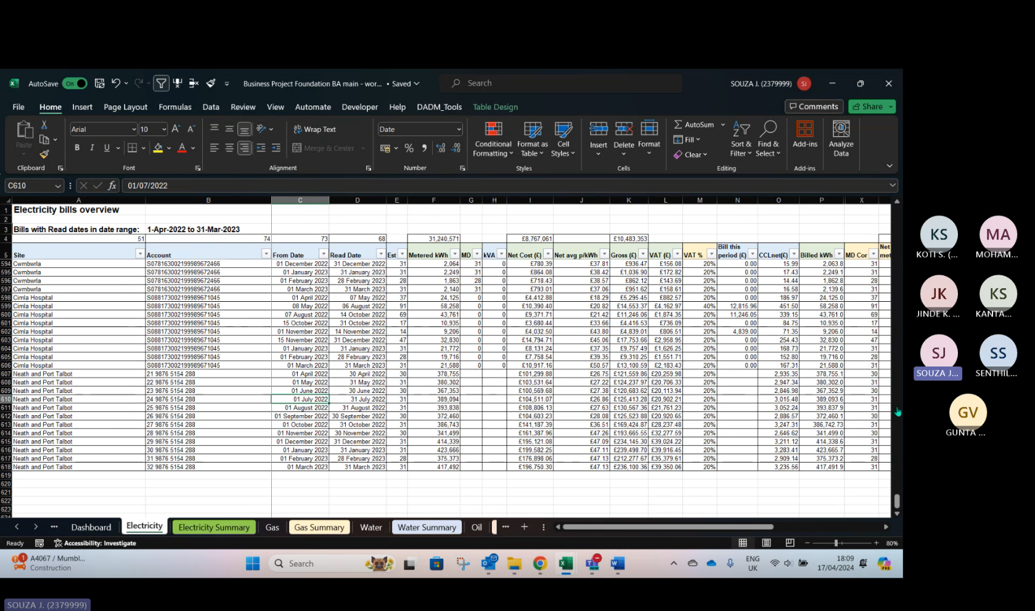
Microsoft Teams session during project kick-off meeting, capturing vital discussions and collaborative planning efforts.
Data Restructuring and Dashboard Creation
This milestone marks the completion of restructuring the NHS energy data to enhance its usability and accessibility for analysis. Team members dedicated their efforts to restructure the raw data, including cleaning, standardizing, and organizing it into a format conducive to analysis. This involved meticulous processes such as removing unnecessary rows and columns, identifying and rectifying outliers or missing data points, and ensuring consistency in data entry formats. With the data now refined and standardized, the team proceeded to leverage data visualization tools to craft interactive dashboards. These dashboards serve as dynamic platforms that visually represent key insights and trends in energy consumption across NHS facilities in Swansea. By providing stakeholders with a user-friendly interface, the dashboards empower them to explore the data intuitively, identify patterns, and make informed decisions regarding cost-saving opportunities. The successful completion of this milestone signifies a significant step forward in unlocking actionable insights from the NHS energy data, driving progress towards achieving the project's objectives.
Data Analysis and Insights Generation
In this phase, the project team will delve into the analyzed dataset to uncover meaningful patterns, trends, and insights related to energy consumption within NHS facilities. Utilizing statistical methods, data visualization techniques, and domain expertise, team members will explore various factors influencing energy usage, such as seasonal variations, facility size, and equipment efficiency. The objective is to derive actionable insights that inform cost-saving strategies and optimization initiatives across NHS facilities.
Visualization and Report Drafting
Description: The visualization and report drafting phase involve transforming the analyzed data and insights into compelling visualizations and comprehensive reports. Visualizations, including charts, graphs, and diagrams, will be created to present key findings and trends in an accessible and engaging format. Concurrently, the project team will draft the project report, outlining the methodology, analysis findings, and recommendations for cost-saving opportunities. Emphasis will be placed on clarity, coherence, and alignment with project objectives.
Stakeholder Presentation and Feedback
The stakeholder presentation serves as a platform to share project findings, insights, and recommendations with key stakeholders within the NHS. During the presentation, team members will provide an overview of the project's methodology, present key findings from the analysis, and discuss actionable recommendations for cost-saving initiatives. Stakeholders will have the opportunity to provide feedback, ask questions, and offer insights, ensuring alignment with organizational goals and objectives.
Final Report Submission
The submission of the final project report represents the culmination of the project's efforts and deliverables. The finalized report will encapsulate the project's methodology, analysis findings, and refined recommendations for cost-saving opportunities. It will be submitted to the project sponsor or designated stakeholders for review and approval, signifying the conclusion of the project and the dissemination of actionable insights to inform decision-making within the NHS.
Project Review and Lessons Learned
The project review and lessons learned session provide an opportunity for team members to reflect on the project's outcomes, processes, and challenges. During this session, successes and areas for improvement will be identified, and lessons learned will be documented for future projects. By capturing insights and experiences gained throughout the project, the team can enhance project management practices, refine methodologies, and foster continuous improvement in future endeavours.

III. Required Resources:
Resources required for project completion include access to NHS energy data and reports, computer software for data analysis and visualization (e.g., Excel, Tableau), collaborative tools for communication and document sharing (e.g., Google Drive, Microsoft Teams), and relevant literature on energy management and cost-saving strategies.
By adhering to these methodologies and utilizing the identified desk-based data sources, we aim to effectively analyse NHS energy data and derive actionable insights for cost savings within NHS facilities in Swansea. In summary, our project methodology embodies a systematic and rigorous approach to leveraging desk-based data sources for energy data analysis within NHS facilities. By adhering to our meticulously crafted methodology, we aim to unravel valuable insights and recommendations for optimizing energy usage and achieving cost savings, thereby contributing to the overarching goal of enhancing sustainability and efficiency within NHS facilities in Swansea.

Existing changes and advantages
changes made | EXISTING CHANGES | ADVANTAGES
Data Organization into a simple format. | Raw data from NHS was disorganized and complex. | Clear visualization of key commodity trends.
 | Team organized data into a user-friendly format. | Clear visualization of key commodity trends.
 | Data structured to include relevant information. | Clear visualization of key commodity trends.
 | Format designed for easy comprehension and usage. | Clear visualization of key commodity trends.
Data organization to address missing data | Original data had significant missing entries. | Clear visualization of key commodity trends.
 | Team identified and addressed missing data points | Clear visualization of key commodity trends.
 | Data organized in a structured manner. | Clear visualization of key commodity trends.
 | Dashboard designed to summarize annual data. | Clear visualization of key commodity trends.
 | Included tables and visualizations for each commodity. | Enhanced understanding of data through charts.
 | Provided insights into overall energy consumption
Creation of Neath and Port Talbot dashboard | Specific dashboard created for Neath and Port Talbot | Specific insights for individual hospital data
 | Dashboard tailored to reflect unique data points. | Improved decision-making for targeted areas.
Conversion of large dataset into insightful form | Large dataset from NHS required organization. | Increased usability of data for decision-making.
 | Team converted data into user-friendly format. | Streamlined data interpretation through visualization.
 | Insights derived from complex dataset. | Enhanced understanding of energy consumption trends.

Changes Made | Details | Advantages
Data organization into a simple format | The raw data received from the NHS was unstructured, containing various data points without a clear organization or format. This made it challenging for stakeholders, especially those without technical backgrounds, to understand and analyse the data effectively. The team meticulously organized the data into a simplified format that was easy to comprehend and navigate. Data points were categorized and arranged systematically, making it more accessible for all users. Furthermore, the format was designed to accommodate future updates and modifications, ensuring scalability and adaptability. | Enhanced accessibility: The simplified format made it easier for stakeholders, including non-technical users, to access and interpret the data, promoting widespread use and understanding. - Simplified data analysis: The organized format facilitated straightforward data analysis, enabling stakeholders to derive insights and make informed decisions more efficiently.
Data organization to address missing data | Upon reviewing the raw data, it was evident that there were numerous missing entries and inconsistencies throughout the dataset. To address this issue, the team conducted a thorough examination of the data to identify and rectify missing data points. Using data validation techniques, they verified and supplemented missing entries where necessary, ensuring data completeness and accuracy. Additionally, data organization techniques, such as structuring and labelling, were employed to enhance data integrity and reliability. The organized data was designed to allow for easy editing and updating, enabling stakeholders to maintain data accuracy over time. | Clear visualization of key commodity trends: The dashboard presented energy consumption trends in a visually appealing and comprehensible manner, enabling stakeholders to grasp key insights briefly.  Enhanced understanding of data through charts: By incorporating visualizations, the dashboard facilitated a clearer understanding of complex data, making it easier for stakeholders to interpret and analyse the information effectively.
Creation of Neath and Port Talbot dashboard | Recognizing the need for localized insights, the team created a separate dashboard specifically for Neath and Port Talbot hospitals. This tailored dashboard focused on providing detailed analyses and visualizations of energy consumption data unique to these hospitals. The dashboard highlighted specific trends, challenges, and opportunities relevant to each facility, allowing stakeholders to make informed decisions tailored to their respective contexts. Customized features and functionalities were integrated into the dashboard to cater to the specific needs and preferences of Neath and Port Talbot stakeholders. | Specific insights for individual hospital data: The tailored dashboard provided Neath and Port Talbot stakeholders with targeted insights into their energy consumption patterns, enabling them to identify areas for improvement and optimization. - Improved decision-making for targeted areas: By focusing on localized data, the dashboard facilitated more informed decision-making at the hospital level, empowering stakeholders to implement targeted strategies for cost-saving and efficiency enhancement.
Conversion of large dataset into insightful form | The team encountered a large and complex dataset from the NHS, which required extensive organization and structuring to derive meaningful insights. Leveraging data processing and visualization tools, they transformed the raw dataset into an insightful format that facilitated data analysis and interpretation. Complex data points were distilled into clear and concise summaries, enabling stakeholders to extract actionable insights efficiently. The converted dataset was presented in a user-friendly format, featuring intuitive navigation and interactive elements to enhance user engagement. | Increased usability of data for decision-making: The conversion of the dataset into an insightful form enhanced its usability, making it more accessible and actionable for stakeholders involved in decision-making processes. - Streamlined data interpretation through visualization: By presenting data in a visual format, the converted dataset facilitated easier interpretation and analysis, enabling stakeholders to identify trends and patterns more effectively. - Enhanced understanding of energy consumption trends: The organized and structured format of the converted dataset provided stakeholders with a deeper understanding of energy consumption trends, empowering them to make informed decisions regarding cost-saving initiatives and resource allocation.

